1. Write a C program that finds a path to travel from a city to another city (It doesn’t have to be shortest way), also print the distance travelled.

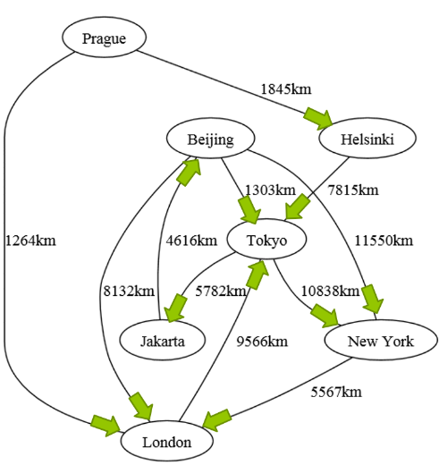

Example Prompt:

